PLANT GROWTH AND GAS EXCHANGE
STUDENT PAGES (READINGS)

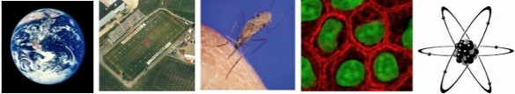

Culturally relevant ecology, learning progressions and environmental literacy
John Moore, Colorado State University, Principal Investigator

Environmental Literacy Project
http://edr1.educ.msu.edu/EnvironmentalLit/index.htm

Eric Keeling, Dijanna Figueroa, Jonathon Schramm, Lindsey Mohan, and Charles W. Anderson
With help from Cheryl Hach, Becky Drayton, Dante Cisterna, and Lori Spindler

November, 2010

Development of these materials is supported by a grant from the National Science Foundation: Targeted Partnership: Culturally relevant ecology, learning progressions and environmental literacy (NSF-0832173), with additional support from Developing a Research-based Learning Progression for the Role of Carbon in Environmental Systems (REC 0529636), Learning Progression on Carbon-Transforming Processes in Socio-Ecological Systems (NSF 0815993), and the Great Lakes Bioenergy Research Center. Any opinions, findings, and conclusions or recommendations expressed in this material are those of the author(s) and do not necessarily reflect the views of the National Science Foundation or the Department of Energy.

Contents
Activity 4: The Molecules of Air, Plants, and Soil 2
Activity 8: Photosynthesis and Cellular Respiration 6
Activity 10: Von Helmont’s Willow Tree 8

Activity 4: The Molecules of Air, Plants, and Soil
Here are a couple of important ideas about matter:
- All matter—all solids, liquids, and gases, including the matter in living things—is made of atoms.
- Atoms are usually bonded together in molecules.
This lesson is about the atoms and molecules of three important systems that you will need to know about in order to explain how plants grow: air, plants and soil.

Part 1. The Molecules of Air
We speak of air as light, "airy," or even as nothing. But what is air made of? Let’s answer that question at different scales.
At the macroscopic scale, air appears to be just a gas that we can feel and breathe, but not see. Sometimes we can see things suspended in air, such as dust (little solid particles), smoke (also little solid particles), fog (little drops of water), and clouds (little drops of water or crystals of ice). What we cannot see is that air itself is actually a mixture of transparent, odorless gases that we can detect with special sensors, but not with our own senses.
At the microscopic scale, we can see the individual particles of some of the other substances in air, including dust, germs, bacteria, smoke, and many others. Most substances that you can see in the air, like fog or smoke, are made of solid or liquid particles that contain trillions of molecules each (Remember the Powers of 10 chart!).
At the atomic-molecular scale, air is made of different kinds of gas molecules. The composition of air in the atmosphere changes slightly from moment to moment and place to place, but approximately 78% is nitrogen (N₂), 21 % is oxygen (O₂), 1% is argon (Ar), and .03% is Carbon Dioxide (CO₂). There are other trace gases in air, such as hydrogen, helium, and neon. Water vapor (H₂O) is also a gas found in air. Water vapor ranges between 0-3% depending on the temperature and humidity.
Molecules are made of atoms bonded together. The pictures below show images of several key molecules in air. The images use a color code to represent each type of atom:
- Hydrogen- white
- Oxygen- red
- Carbon- black
- Nitrogen- orange
Oxygen (O₂) Water Vapor (H₂O)

WATER MOLECULE

Carbon Dioxide (CO₂) Nitrogen (N₂)

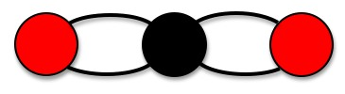

Here are some key facts to remember about the molecules of air:
- Air is almost entirely made of a few kinds of molecules, including N₂, O₂, and H₂O (water vapor), with only a small amount (0.03%) of CO₂ (carbon dioxide).
- The molecules of air are small and simple.

Part 2: The Molecules of Plants
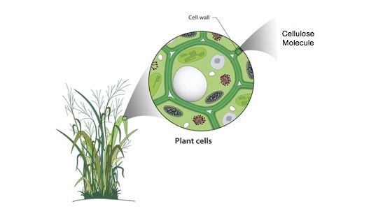
We can also look at plants at different scales
At the macroscopic scale, we see the parts of plants—stems, leaves, roots, flowers, seeds.
At the microscopic scale, we can see that plants are made of cells, and that the cells have smaller parts such as cell walls, nuclei, and chloroplasts. These parts (called organelles) are important, but we will not study them in this unit. Every plant cell and every organelle contains trillions of molecules.
At the atomic-molecular scale, cells are made of molecules, but these molecules look very different from the molecules of air—with one exception. Most of the molecules in plant cells are actually water—good old H₂O. In plants, the water is in liquid form, different from the water vapor in the air.
But what about the other molecules in plants? What are the SOLID parts of plant cells made of? Below we have images of some of the common molecules that make up plants. Since these molecules are much larger than the molecules of air, we will use letters to show the kinds of atoms:
- Hydrogen- H
- Oxygen- O
- Carbon- C
- Nitrogen- N
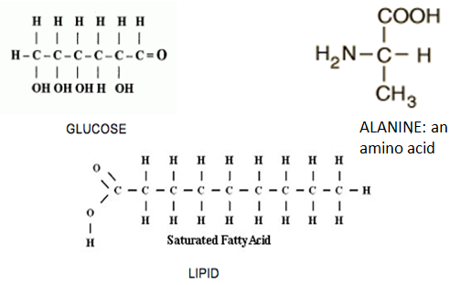
OH H
Here are two important things to understand about the molecules in plants.
1. The molecules of plants are big and complex. The molecules shown above are much bigger than the molecules of air, but most of the molecules in plant cells are even bigger. They are made of lots of these kinds of molecules bonded together. You have probably heard of some of these big molecules in plants:
- Cellulose, the main structural component of cell walls (and of plant stems, wood, cotton, and paper) is made of many glucose molecules bonded together.
- Starches are made of glucose (and other sugar) molecules bonded together.
- Proteins are made of amino acid molecules bonded together.
- Fats are made of fatty acid molecules bonded together (with another molecule called glycerol).
2. The molecules of plants have stored energy. In general molecules that have C-C and C-H bonds have lots of energy. That means when you see a molecule where carbon is bonded to another carbon, or where carbon is bonded to hydrogen, that molecule has lots of chemical energy. Some molecules are not rich with chemical energy. These molecules contain O-H and O-C bonds. Materials that only include oxygen bonded to hydrogen or oxygen bonded to carbon are not chemical energy sources.
Chemists call molecules with C-C and C-H bonds organic molecules. Molecules that do not have C-C or C-H bonds are called inorganic molecules. So here are some questions to think about:
- Is water organic or inorganic?
- Are cellulose, starches, proteins, and fats organic or inorganic?
- Are the molecules of air organic or inorganic?

3. The Molecules of Soil
We know that plants grow in soil. But what is soil made of? And what do plants get from soil that helps them grow? We can answer these questions by looking at soil at different scales:
At the macroscopic scale, we can see that different kinds of soil differ in color, texture, and how moist they are, but we can’t see the smaller parts that account for these differences in the appearance of different kinds of soil.
At the microscopic scale, we can see the individual particles of some of the materials in soil. Here are some of the things that we can see looking at soil through a microscope:
- One kind of liquid—good old water, with different kinds of minerals dissolved in it.
- Microscopic living organisms—fungi, protists, and bacteria.
- Humus or soil organic matter—little bits of dead plants and animals.
- Bits of inorganic matter—broken down rocks. These include sand (the largest particles), silt (smaller particles), and clay (still smaller particles).
All of these parts of soil are interesting to study, but here’s something important for our unit on plants: Plant roots cannot take in solid materials from soil.
At the atomic-molecular scale, we will think about only the liquid part of the soil—the materials in soil that plants can absorb through their roots. This is mostly water, of course, but there are also minerals or plant nutrients dissolved in the water. Here are illustrations of water and the two most important nutrients: nitrate and phosphate ions (Ions are like molecules with an electric charge). We will use letters to represent the different atoms:
- Hydrogen- H
- Oxygen- O
- Nitrogen- N
- Phosphorous – P

Water Nitrate Phosphate
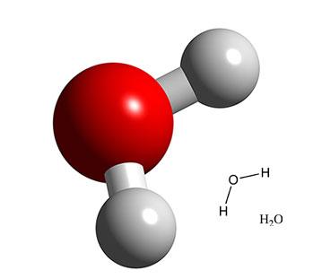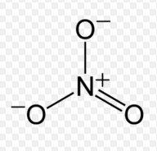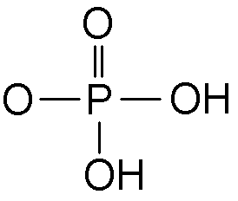

Note that water and soil minerals are inorganic, so they do not have any high-energy C-C or C-H bonds.

A Question for the Next Lessons
So here’s a quick summary of the nature of the molecules in air, plants, and soil.
- Air is made of small inorganic molecules, including N₂, O₂, H₂O, and CO₂.
- Plants are made of lots of H₂O, but also large organic molecules, including cellulose, starches, proteins, and fats. These molecules have energy stored in their C-C and C-H bonds.
- Soil is made of lots of different materials, but the only materials that plant roots can absorb are H₂O, with dissolved minerals like nitrate (NO₃⁻) or phosphate (PO₄⁻⁻⁻).
So that leaves us with our question for the rest of the unit: Where do those large, organic, high energy molecules in plants come from?

Activity 8: Photosynthesis and Cellular Respiration
As you discovered in the last few activities, gases, including carbon dioxide (CO₂) have mass just as any other form of matter does. In addition, growing plants
- decrease the concentration of CO₂ in the air around them while in the light, and,
- increase the concentration of CO₂ when the plants are kept in the dark.
So why is this significant for plants? What’s happening inside them when they take in or release CO₂, and why do plants do that?
Photosynthesis is a term often used in describing plants. It describes plant cells constructing sugars (glucose) from carbon dioxide & water in the presence of light energy (photo = light, synthesis = ‘putting together’). The key idea is this:

Plants store some of the energy of sunlight within the glucose that they make during photosynthesis in their leaves.

Remember that we discussed previously the idea of stored chemical energy held in the bonds between the atoms of molecules. In the case of glucose, carbon – carbon and carbon-hydrogen bonds are common and store abundant energy. Notice that glucose has many more of these bonds than either water or carbon dioxide.
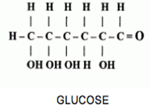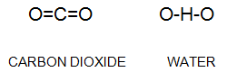
OH H
Inside the leaf cells of plants is a molecule called chlorophyll. Chlorophyll has the ability to capture the energy of sunlight. The light energy then breaks the bonds holding the atoms together in the water and carbon dioxide molecules. The atoms form new molecules of oxygen and glucose. In this process the light energy from the sun is changed (transformed) into chemical energy that’s stored in the glucose molecule. Expressed as a chemical formula, photosynthesis looks like this:

MATTER 6 H₂O + 6 CO₂ → C₆H₁₂O₆ + 6 O₂
ENERGY Light Energy → Chemical Energy + Heat

As you can see from the equation above, glucose is composed of carbon, hydrogen, and oxygen atoms – the very same carbon, oxygen, and hydrogen atoms that were originally found in the carbon dioxide and water. However, the energy of sunlight has been captured in the bonds between these atoms (as chemical energy) in the glucose molecules.
So now what? What does the plant do with all of this glucose that it has been making during photosynthesis?
Plants send the glucose that they make to cells in all parts of the plant-- roots, stems, leaves, flowers, and fruits. The cells in those parts use the glucose they make for two main purposes.
Each plant cell uses glucose in two ways:
1. as a source of atoms for growth (making new molecules)
2. as a source of energy (for doing life’s processes)

The ways in which plants use glucose for making new molecules are complicated, and we’ll discuss them more in an upcoming lesson. In essence, plants take the glucose they make and use enzymes to build bigger molecules such as fats, proteins, and carbohydrates. These molecules are the building blocks for the new cells and organelles of the plant.
But how do you think plants release the energy of glucose to use it to do work? Plants combine glucose molecules with oxygen in a process called cellular respiration. Breaking down the molecules releases the stored energy and allows plants to use it for work at the cellular level. So to summarize, cellular respiration is the process by which cells change (transform) the chemical potential energy found in glucose into usable, motion energy and heat:
MATTER Glucose + Oxygen → Carbon dioxide + Water
ENERGY Chemical Potential Energy → Energy for plant functions + Heat

Plants are not the only organisms that engage in cellular respiration. This process is identical to the way you, dogs, mushrooms, and bees (and many, many other living things) use food and oxygen for energy. So here’s an explanation for how plants change the concentrations of CO₂ inside the chambers.
- In the dark, plant cells are getting energy for their functions through cellular respiration. They release the chemical potential energy stored in the bonds of glucose by combining it with oxygen to produce carbon dioxide.
- In bright light plants are still using glucose for cellular respiration and releasing CO₂, but they are making even more glucose than they are releasing through photosynthesis, and using CO₂ to make the glucose.
So that explains what is happening to gases. Next we will study what happens to the mass of plants.

Activity 10: Von Helmont’s Willow Tree
An experiment from long ago...
Let's travel back in time 360 years. It is now the year 1642. We are in Europe. It is a time of excitement and exploration. More people are getting interested in finding out about the world around us. We are going to meet one of these early scientists. He is a medical doctor but he also does experiments with plants. His name is Dr. Jan von Helmont, and he is from the country of Belgium. He is going to help us think through our question about whether soil is food for plants, a question he was also very interested in.
Almost everyone back in 1642 thought that soil was food for the plants. Von Helmont did an experiment to see if this was true. He planted a 5-pound young tree in a bucket containing 200 pounds of soil. He watered the tree regularly but he did not add any more soil. After 5 years he weighed the tree and bucket again. Here are his results:
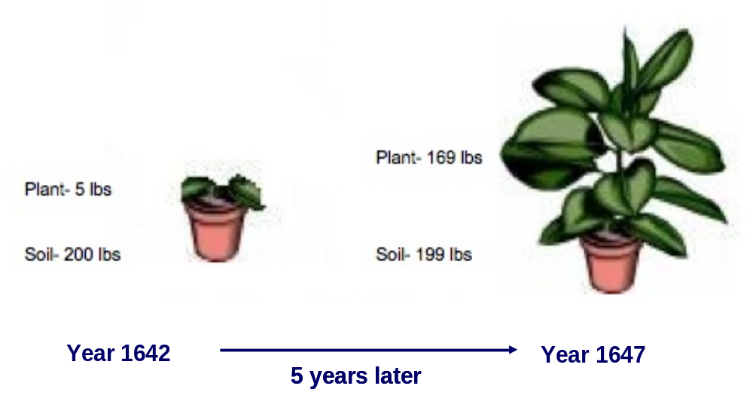
Look at the picture above. Can you figure out if the tree and soil each lost or gained weight in the 5 years that the plant grew?
von Helmont found that the soil lost a little weight while the willow tree gained a lot of weight. How could this happen?
Von Helmont thought that he knew the answer—he believed that he had proved that water was the source of the plant’s weight. This was a reasonable conclusion, but von Helmont didn’t have all the evidence he needed. He didn’t have any way of detecting CO₂ in the atmosphere—he didn’t even know that CO₂ existed!
So later scientists reached a different conclusion—the plant’s weight came mostly from CO₂, not water, and it came into the plant through the process of photosynthesis, converting carbon dioxide and water into glucose.
But that leads to another question: Plants aren’t made just of glucose; they are made of many different kinds of complex organic molecules, such as cellulose, starch, fats, and proteins. Where did all of those molecules come from? This is a puzzle that scientists have worked on for many years.
Plants: Even more complex than von Helmont knew!
It turns out that plants are pretty amazing. They can rearrange the atoms in glucose and soil minerals into all kinds of different molecules! For example, let’s consider the kinds of molecules that we studied in Activity 4, and how plants can make each of them:
- Cellulose, the main structural component of cell walls (and of plant stems, wood, cotton, and paper) is made of many glucose molecules bonded together. Plants can make cellulose from glucose.
- Starches are made of glucose (and other sugar) molecules bonded together. Plants can also make starches from glucose.
- Fats are made of fatty acid molecules bonded together (which another molecule called glycerol). Fats don’t contain glucose, but they are made of the same atoms—C, H, and O—as glucose, so plants can make fats by rearranging the C, H, and O atoms in glucose.
- Proteins are made of amino acid molecules bonded together. Proteins are made mostly of the same atoms as glucose—C, H, and O. But amino acids have other atoms, too, such as N, P (phosphorous), and S (sulfur). Plants can rearrange atoms to make new molecules, but they can’t make new atoms. So how can plants make proteins?
Maybe you have thought about an answer to the last question. Let’s consider the key things that plants need to grow, and how the plants use each one:
- Water. Much of the weight of plants is actually water, and also that water is one of the two key ingredients for photosynthesis.
- Air. Air contains carbon dioxide which plants use for photosynthesis, as well as oxygen that plants use for cellular respiration.
- Sunlight. Sunlight provides the energy for photosynthesis, and the energy of sunlight is stored in the high-energy C-C and C-H bonds of organic molecules. So plants can make glucose, cellulose, starches, and fats out of just these ingredients—H₂O and CO₂, with sunlight providing the energy for the bonds. But what about proteins?
- Soil minerals. There is one more thing that is essential for plant growth, and now we can see why: Soil minerals contain the other atoms, such as N, P, and S, that plants need to make proteins and other essential molecules.
So plants can create all the molecules that they are made of—cellulose, starches, fats, proteins, and many others—from glucose and a few soil minerals. They use the new molecules to form new cells that make up structures like woody stems and roots, flowers, fruits and seeds. This process of reorganizing materials is known as biosynthesis.
Now we have the modern scientific explanation for von Helmont’s results: The soil lost a little weight because some of the soil minerals were taken up by the willow tree and used to make proteins and other molecules. The willow tree gained a lot of weight because most of the molecules of the plant are made by rearranging the C, H, and O atoms of glucose.
Just for fun, we have included a page that shows some (not all!) of the biosynthesis pathways in plants. (To save space, this page represents atoms in molecules in a little different way from the structures we have shown before. Carbon atoms are shown as ends of lines or bends in lines; hydrogen atoms are not shown at all. It’s not important at this point to know the details, but notice that everything starts with glucose, highlighted with a circle. The rounded rectangle shows the molecules modified from chains of glucose molecules, such as starch and cellulose. The diamond indicates fats and other lipid molecules. The majority of the other molecules in the diagram are present in much smaller amounts within plants, such as cholesterol, plant hormones, and a huge variety of molecules that the plants can use as defense against herbivores. Incidentally, many of these compounds are what provide the unique tastes of plants for humans!
So now that we’ve discussed how plants gain their mass (primarily photosynthesis) and move the products of photosynthesis into other complex molecules throughout their body (biosynthesis), how and when do plants lose mass? Did von Helmont’s plant (or yours) retain all of the matter that it incorporated during photosynthesis, or did it also lose some during that five year period?
Think about what would happen to von Helmont’s tree during the winter months if it was left outside. His tree was a willow, a deciduous species, and would have lost all of its leaves during the winter. Yet the cells inside the tree would still be alive and would have to maintain some of their functions. Think about what process would allow them to do so, and what the reactant is that they would need to complete this process.
In fact, you’ve witnessed the effect of this process when you observed gas exchange in the dark with your bean plants. What happened with the carbon dioxide levels in the aquarium in the dark?
Of course, plant cells, like all cells, need to undergo this process at all times in order to maintain life. So they are giving off CO₂ all the time, but when the conditions are right for photosynthesis, they end up taking in more to make glucose than they are giving off.

***Now return to your handout to complete the activity...
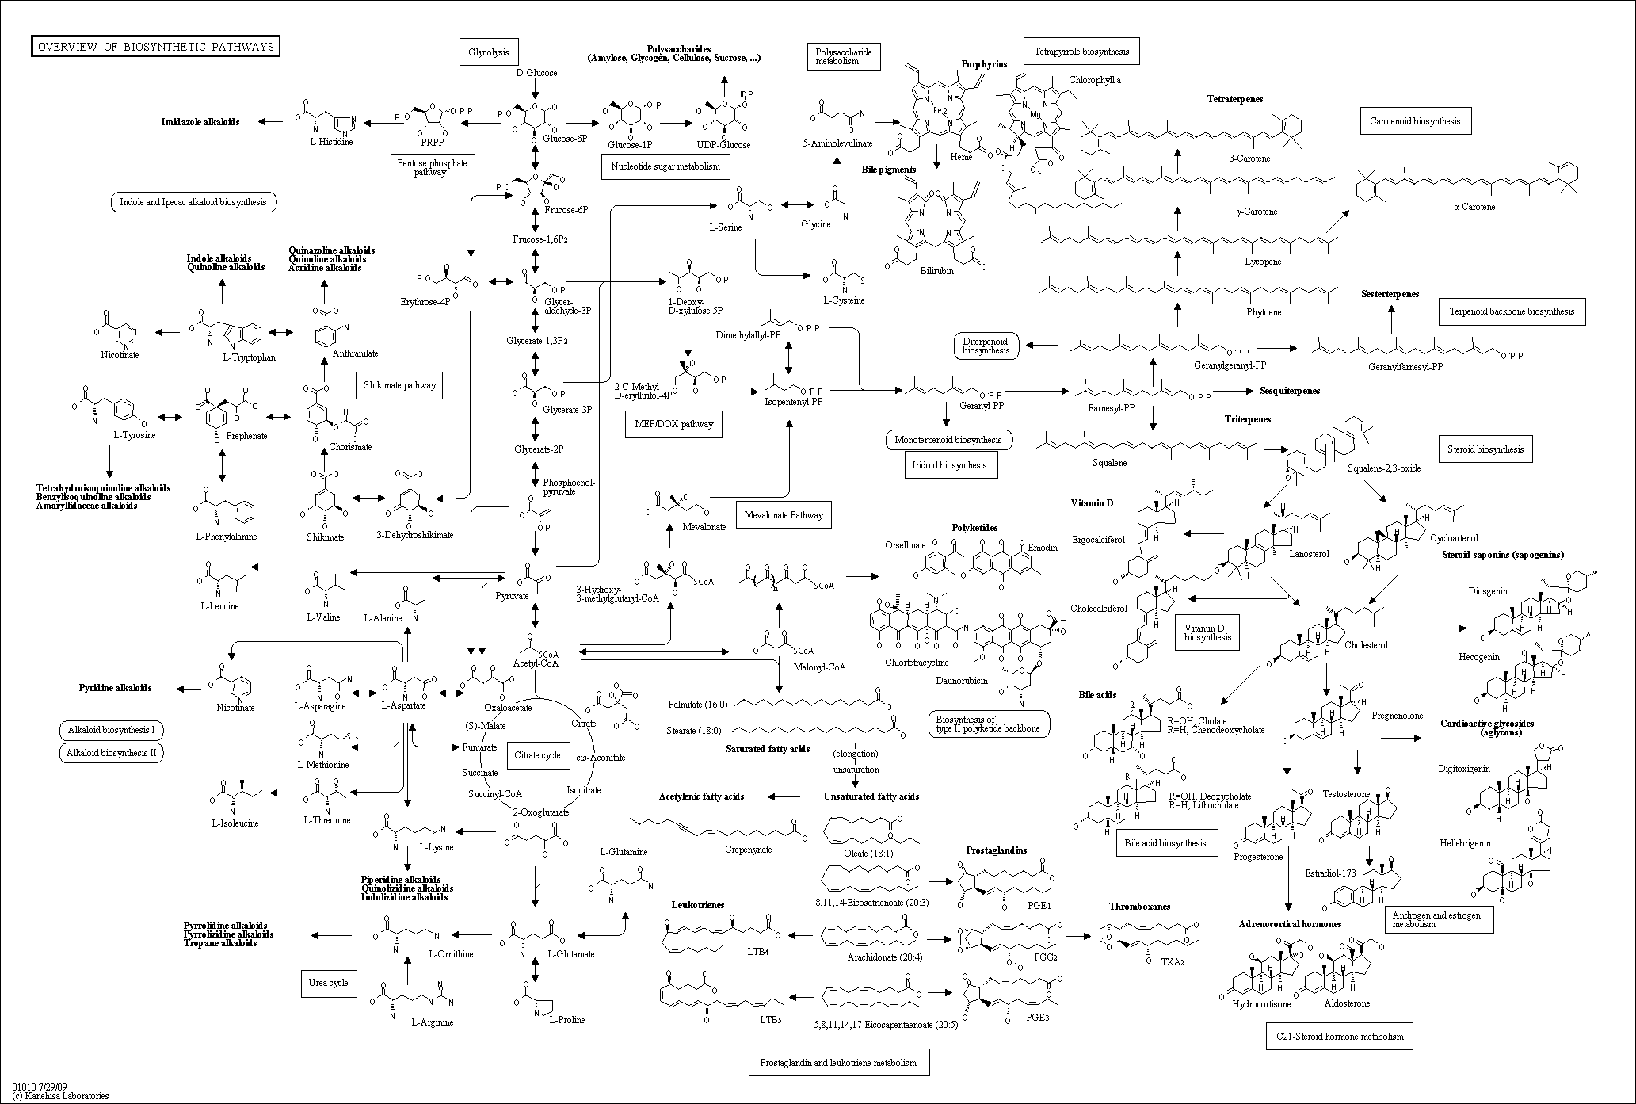
Source: www.genome.jp

